Chapter 4

Manufacturing Process Used in the Formation of Alumina

- Cutting
- Grinding
- Drilling
- Filing
- Marking
- Punching
- Holding
- Hammering
- Assembling

4.1 Cutting:
Cutting is the basic start for this project which is being done with the help of glinder, Glinder contains a blade which is rotated at a fixed speed through which a required force is generated for the cutting. In our project cutting is done on the aluminum sheet after the markings.
“Cutting is the separation of a physical object, into two or more portions, through the application of an acutely directed force. Implements commonly used for cutting are the knife and saw, or in medicine and science the scalpel and microtome”.
Cutting is a compressive and shearing phenomenon, and occurs only when the total stress generated by the cutting implement exceeds the ultimate strength of the material of the object being cut.

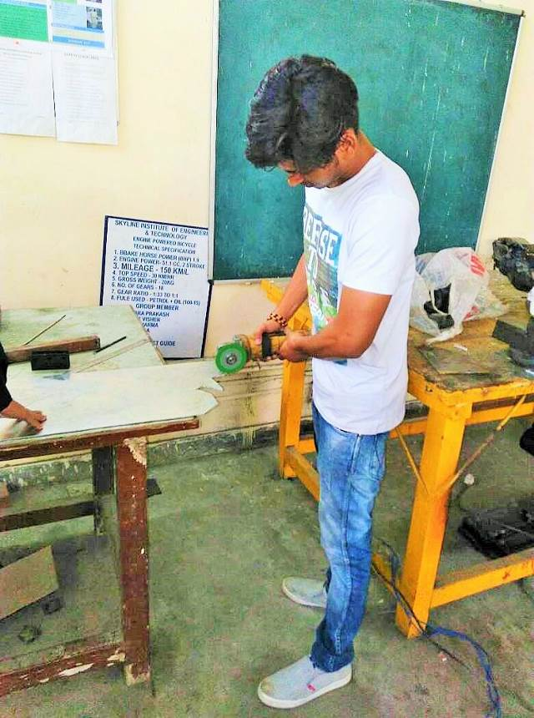
Fig: - 4.1 (Cutting operation performed by Glinder)

4.2 Grinding:
The Grinding Process was carried out and it was a major activity because the surface properties & surface condition of the aluminum sheet has its importance.
So in this process after the cutting of sheet Grinding is done to ensure the smoothness of the surface of the parts. Grinding process can be executed in a different ways, the method which we adopted in this project is the conventional grinding process with the help of Grinding Machine available in our Manufacturing workshop. This method requires some safety measures such as gloves & glasses to protect our hands & eyes. This machine comprises of a rotating roller of composites alloy which helps in shaping & smoothing of the surface when it comes in contact with it while rotating.

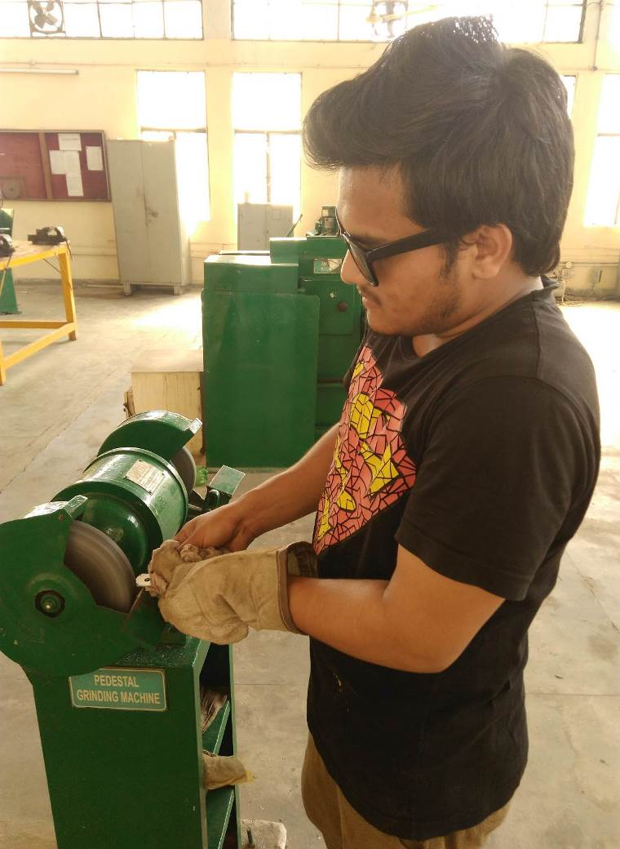
Fig: - 4.2 (Performing Grinding Operation)
4.3 Drilling:
In our Project Drilling is done by the Geared head dill machine in which the X & Y axis is defined by the bed or Z axis is defines the dill axis up & down.
A geared head drill press is a drill press in which power transmission from the motor to the spindle is achieved solely through spur gearing inside the machine's head. No friction elements (e.g., belts) of any kind are used, which assures a positive drive at all times and minimizes maintenance requirements.
Gear head drills are intended for metalworking applications where the drilling forces are higher and the desired speed (RPM) is lower than that used for woodworking. Geared head drill presses are commonly found in tool rooms and other commercial environments where a heavy duty machine capable of production drilling and quick setup changes is required. In most cases, the spindle is machined to accept Morse taper tooling for greater flexibility. Larger geared head drill presses are frequently fitted with power feed on the quill mechanism, with an arrangement to disengage the feed when a certain drill depth has been achieved or in the event of excessive travel.
Drilling is a cutting process that uses a drill bit to cut a hole of circular cross-section in solid materials. The drill bit is usually a rotary cutting tool, often multipoint. The bit is pressed against the work piece and rotated at rates from hundreds to thousands of revolutions per minute.
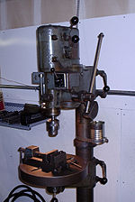
Fig: - 4.3 (Geared Head Drill Machine)
4.4 Filing:
After grinding process, then we proceeded to the filing of the aluminum parts formed by the sheets. The main objective of filing was to provide perfect finishing to the edges of the aluminum parts. It was used to remove the slight unevenness on the edges which escaped the grinding machine, also it was more precise in the smoothening of the edges.
Basically, in this process we took the use of center file & half round file, where center file was used to cleaning and reaming of the drilled holes & half round file was utilized in shaping & finishing the edges of the parts.
Filing is a material removal process in manufacturing. Similar, depending on use, to both sawing and grinding in effect, it is functionally versatile, but used mostly for finishing operations, namely in deburring operations. Filing operations can be used on a wide range of materials as a finishing operation. Filing helps achieve work piece function by removing some excess material and deburring the surface. Sandpaper may be used as a filing tool for other materials, such as glass.

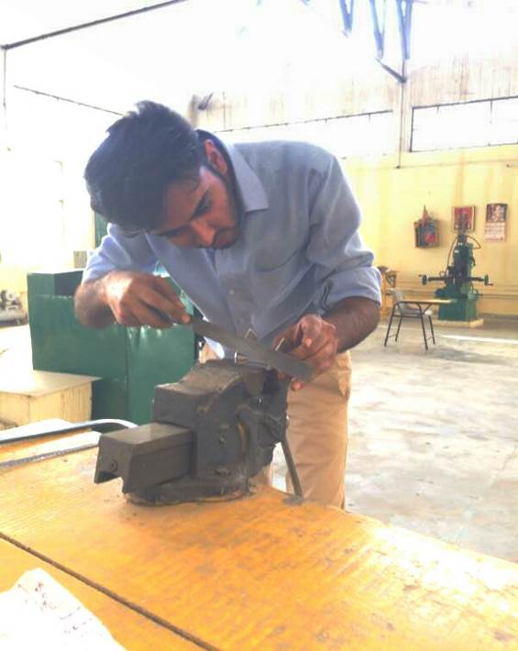
Fig: - 4.4 (Performing Filing operations on the parts of Robot)
4.5 Marking:
In this project, marking is done by the scriber on the aluminum sheet. Marking is basically defined as the process of transferring a design or pattern to a work piece by the help of sketched lines according to the requirements. It is the basic step perform while we do designing or manufacturing of any object with its proper dimensions. In different materials different types of tools required to perform the marking function such as in woods pencil is used. Marking is done with some calculations according to requirement or measure of the design.

4.6 Punching:
Punching is basically done to form an impression by shear force, if the force we applied is large then it is able to make a hole depends on some conditions such as material property.
In our project, punching is performed with the help of center punch or a ball peen hammer to form an impression of center before performing the drilling operation in the aluminum sheet parts such as in oblique brackets, Short U brackets, Long U brackets, Interconnect brackets, L shaped brackets, etc.
We hold the center punch on the center position and apply the force by the ball peen hammer, due to shear force there is an impression formed on the sheet which easily show the exact center for the drilling operation.

4.6.1 Punching Characteristics:
- Punching is the most cost effective process of making holes in strip or sheet metal for average to high fabrication
- It is able to create multiple shaped holes
- Punches and dies are usually fabricated from conventional tool steel or carbides
- Creates a burnished region roll-over, and die break on sidewall of the resulting hole^{[1]}
- It's quick

4.7 Holding:
Holding is basically done by the jigs & fixture where jigs is used to hold & guide the tool & fixtures only hold or support the tool or work piece for the operations. It is done by bench vises in our project, there are different types of vises used in different manufacturing shops for different types of processes. In our project we hold the aluminum sheet parts on the bench vise for the filing & surface finishing process as our requirement, we also used pipe vise for the bending operation in the formation of aluminum clamps for the servo motor with desired specifications according to our need.
The different types of vises used in the manufacturing process for holding the work pieces are as follows:-
- Bench Vise (It is used to hold metal while filing or cutting)
- Vacuum Vise (It is used to hold circuit boards, model airplanes and other works)
- Pipe Vise (It is used to hold the pipes, basically used in plumbing operations)
- Machine Vise (Mounted on dill machine, grinding machine, milling machine to hold the work piece).
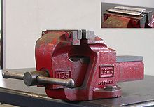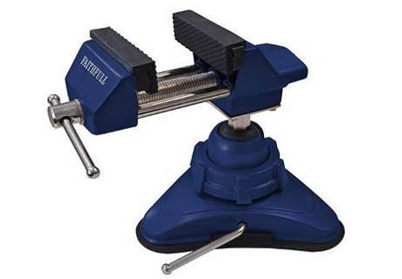
Fig: - 4.5 (Bench Vise) Fig: - 4.6 (Vacuum vise)
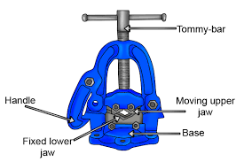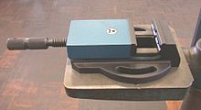
Fig: - 4.7 (Pipe Vise) Fig: - 4.8 (Machine Vise)
4.8 Hammering:
Now to transform the parts according to the desired shape & design hammering was done, this hammering process was carried out by mallet not a regular hammer to avoid unnecessary impressions on the surface of the parts which could have deteriorate its properties.
In this process the bending of the clamps was done by striking it with a mallet until it gained the desired shape.
Hammering is defined as the deformation in structure by heavy force applied by the device named as hammer, this operation apply impact force on the work piece to form into a specified structure according to the requirement or the need. In our Project, it used to form the servo clamps or brackets for the bending operation with the help of mallet which is also a type of hammer & made up of wooden material.

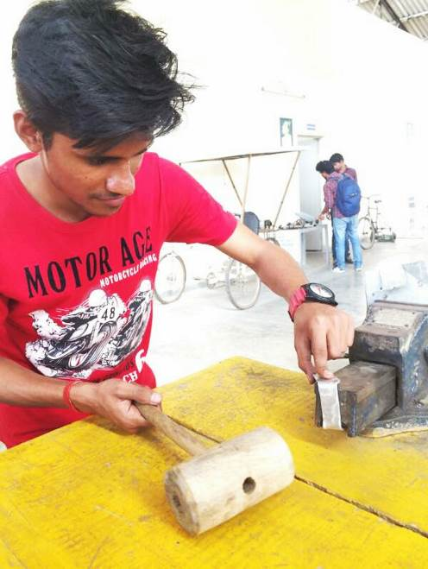
Fig: - 4.9 (Bending the parts by Mallet)
4.9 Assembling:

Step 1:- After the successful execution of all the activities then it was time to assemble all the designed & finished parts to form the desired Structure.
First we installed a servo on Right Robot feet aluminum servo bracket after that the same process was carried to the left Robot feet aluminum servo & similarly all the other parts of the robot were attached along with the servo joined to them. In the assembling of ALUMINA we used Allen nut & bolt to tightened the parts with the help of help of Allen key theses nut & bolt assembly are so perfect to perform the function of joining, there is no chance of loosening the nut from the bolt in that type of assembly of nut & bolts.
In our project first we join the servo motors with their feet by the help of servo brackets, clamps & robot feet aluminum servo brackets.

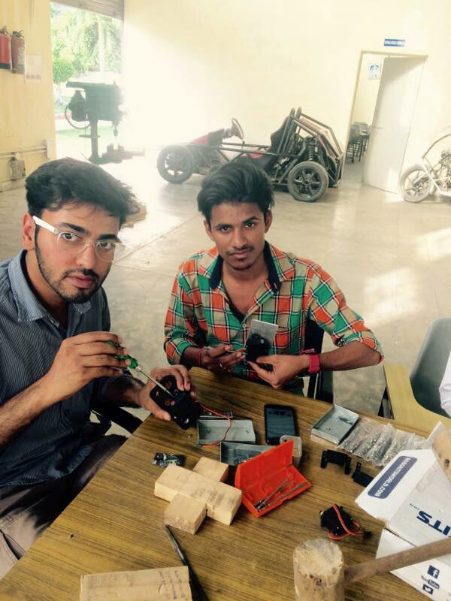
Fig: - 4.10 (Assembling of feet)
Step 2: - In this step we done the formation of legs with the help of U shaped Servo Clamps, Oblique shaped servo brackets, Servo motor & nut & bolt assembly.
We provide the maximum angle moments to thighs are 45 degree in each of the direction as per the consideration we select the servo motors & joining. In our project, formation of thighs or legs takes a lot of time due to lack of knowledge about the tightening the screws & don’t know how to use the Allen key after that we all know the proper use of Allen key effectively with Allen nut.
The servo motors were also connected to the thigh parts of the Alumina when it was joint to the rest of the robot, the thighs were placed while keeping in mind the alignment of the feet of the robot, it alignment was one of the most difficult to execute as the proper shape of the robot was very much depended on it. The servo motors were placed in the Multipurpose Aluminum servo bracket for holding & supporting the motor safely and for connecting them to the U Clamp.
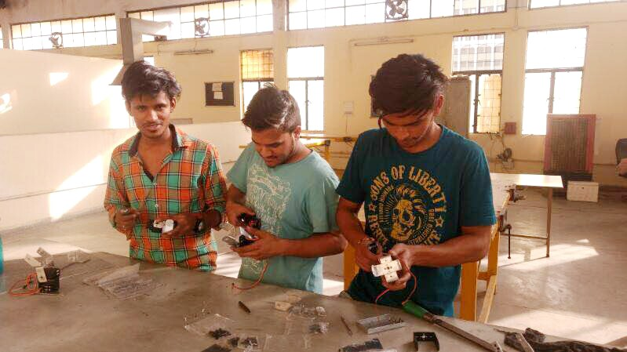

Fig: - 4.11 (Assembling of thighs of ALUMINA)
Step 3: - In this step the formation of belly is done by the Large U beam Aluminum Servo Brackets is connected with 2 multipurpose brackets, 2 L shaped brackets &1 Large U brackets. It is joined by the Big Buttons Screw with lock nuts.
In our project, we placed the battery & Arduino inside the Large U beam Aluminum Servo brackets for the safety of battery & Arduino. After we complete the belly then we go for the preparation of the hands by aluminum brackets & servo. Which is to be connected with the belly with the help of metallic horn & servo motor.
Metals horns were placed in the Long U shaped servo brackets & oblique servo brackets which is going to connect with the servo motors for the proper movement of the servo.
In the formation of the belly we used the designed L shaped Aluminum servo brackets & other brackets which we design for the formation of belly, in our project it is the most important part where we have to place the main circuit of the robot (Arduino Circuit) & Battery (Lithium polymer) so we have to make sure that this portion of the robot be highly secure & safe, a single damage should destroy the functions of ALUMINA.

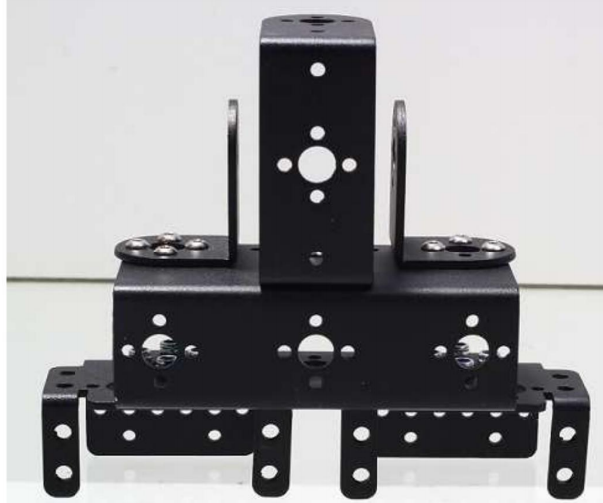
Fig:- 4.12 (Belly connected with aluminum brackets)
Step 4: -
Then it came to assemble the arms with the help of Oblique U shape, interconnected shape, L shape Interconnected Aluminum Servo bracket by using Allen bolt & Lock nut which was tightened with the help of Allen key. The main motive behind using the Allen nut & bolt because of its high efficiency which is due to the presence of plastic fixing constituent material in the bolt which helps in avoiding bond breaking of nut & bolt as it is impossible to reverse it without the help of Allen key. The mechanical hands were connected to the shoulders by joining with the shoulder servo which was moved with the help of Metallic horn.
There should be a major considerations in the formation of hands, basically about the direction of movements of the hands & their servo motor action & their step angle of rotation for the hands. In our project, we make sure that that the movements of hand should be rotate at maximum step angle for the flexibility of the robot. In this project, hands contains two servo motor which provide two motions at different places & one motion is also provide on the shoulder, so we can that the movements of hands or the motion of hands of ALUMIA is 3.

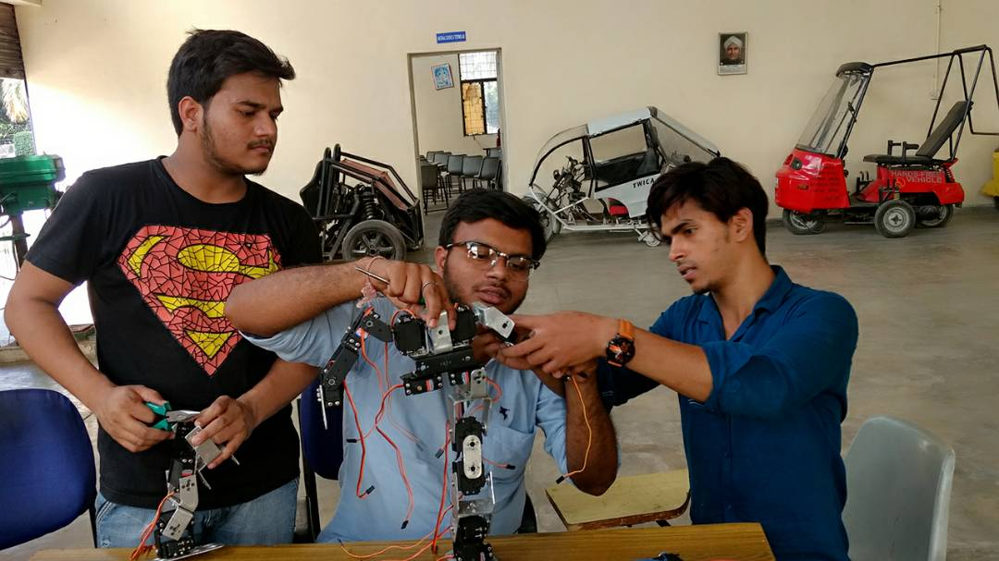
Fig: - 4.13 (Formation of Hands)
Step 4: -
After the complete assembly of all the parts with a lot of difficulties finally the robot came in play for the mechanical action & now we have to the programming parts with the help of Arduino Circuit & Arduino Codes. The mechanical portion is assembled now such as legs are connected with the belly servo, hands are connected with the shoulder servos. The mechanical portion or the part of our robot is done.

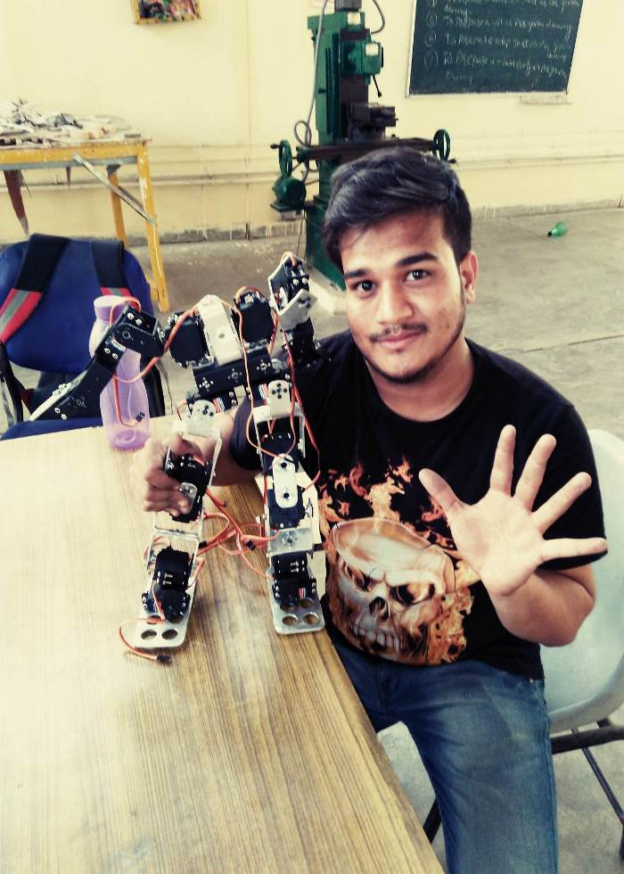
Fig: - 4.14 (Complete formation of Mechanical parts of ALUMINA)

